From the Manufacturer
This Stanley Indoor TimerMax Weekly Digital Timer will turn the electrical devises ON/OFF automatically. Simple programming activates the device on specific days, 7 days a week or weekend only. Includes Battery backup maintains settings during power failures. Vacation mode - timer randomly turns ON and OFF. It has a grounded outlet. It will help save money and energy - in the OFF position, timer cuts power to device, eliminating wasteful standby power. Rating: UL/CUL 120V/10A/1200W Tung,60H.

Product Description
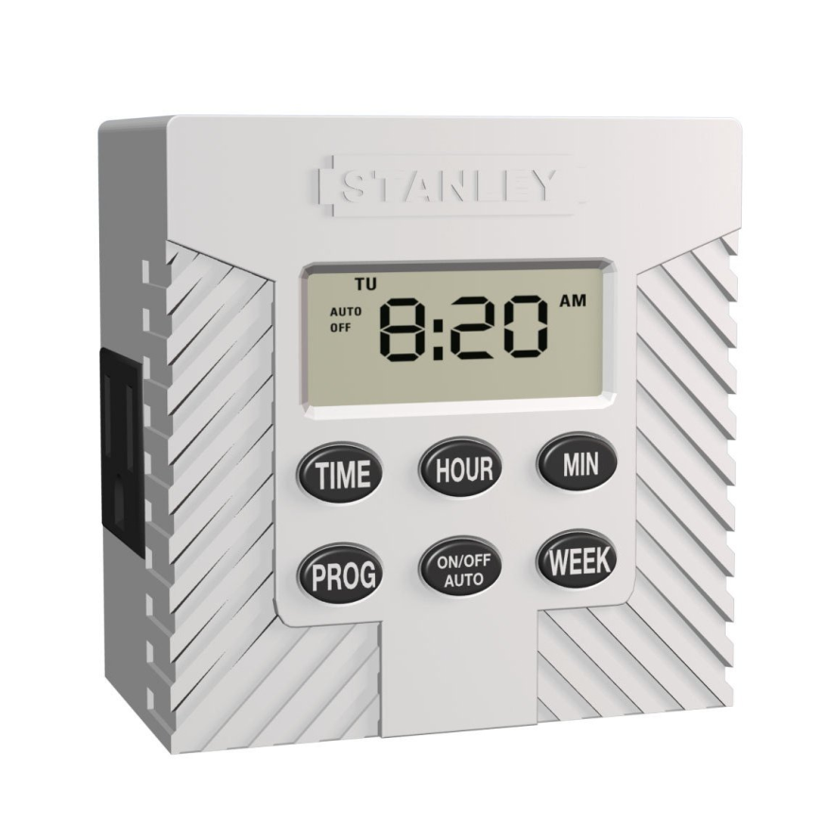
You are buying a Stanley Indoor TimerMax Weekly Digital Timer. This product will turn the electrical devises on and off automatically. Simple programming activates the device on specific days, 7 days a week or weekend only. Battery backup maintains settings during power failures. Vacation mode - timer randomly turns on and off. It has a grounded outlet and plug. It will help save money and energy - in the off position, timer cuts power to device, eliminating wasteful standby power.
http://waterheatertimer.org/pdf/28442_TimerManualEn&Fr.pdf

  - 1
Plug your Stanley TimerMax into a wall outlet. Plug the lamp you want to control into the outlet on the TimerMax.
  - 2
Set your current time by holding the Time button down as you press the Hour and Minute buttons until the current time is displayed.
  - 3
Set the time you want the lamp to turn on by holding down the On button as you press the Hour and Minutes button until the display reads the time you desire.
  - 4
Set the time you want the lamp to turn off by holding down the Off button as you press the Hour and Minutes button until the display reads the time you desire.
